Operation manual

**1. Starting up**

Press and hold the power button for 2 seconds in the power off state, the power light is on, then the power light flashes once to indicate that the power supply self-test is completed.

**2.Adjust Back-lighting**

Press the power button once when the power is on,cycle switching 5 levels back-lighting brightness.

**3.Enter the game**

In the main interface, each name represents a simulator, press the “A” button to enter the corresponding simulator game list;

Select the game you want to play under the list, then press the “A” button to enter the game;

**4.Adjust the volume of Games** (Only for the kernel is the simulator of Retroarch)

If the up and down keys has been set to control volume, pls use “short-cut key” + “↑”

& “short-cut key” + “↓” to control the volume.

(Negative numbers indicate a decrease in volume based on the system volume, positive number is to increase the volume based on the system volume.)

**5.Exit the game**

All the simulators of the Retroarch kernel, press the "hotkey" and "Start" keys at the same time to exit the game;

For simulators which are not the Retroarch kernel, you need to press the "hotkey" to enter the simulator control menu and select the corresponding option to exit the game. Currently, the simulators of the non-Retroarch kernel in the system include NDS and PSP.

**6.Turn off**

Press the START button on the main UI interface, choose QUIT->SHUTDOWN SYSTEM, the system will automatically power off.

**7、Change the default simulator**

The same type of game also has different simulators. For example, the NES game, the system provides three simulators: Ir-fceumm, Ir-nestopie, Ir-quicknes. All three simulators can run the nes game, but some special games can only be run with one of them, which involves the compatibility of the simulator, so sometimes the simulator needs to be changed.

a）In the game loading interface, press any button to enter the simulator selection interface；

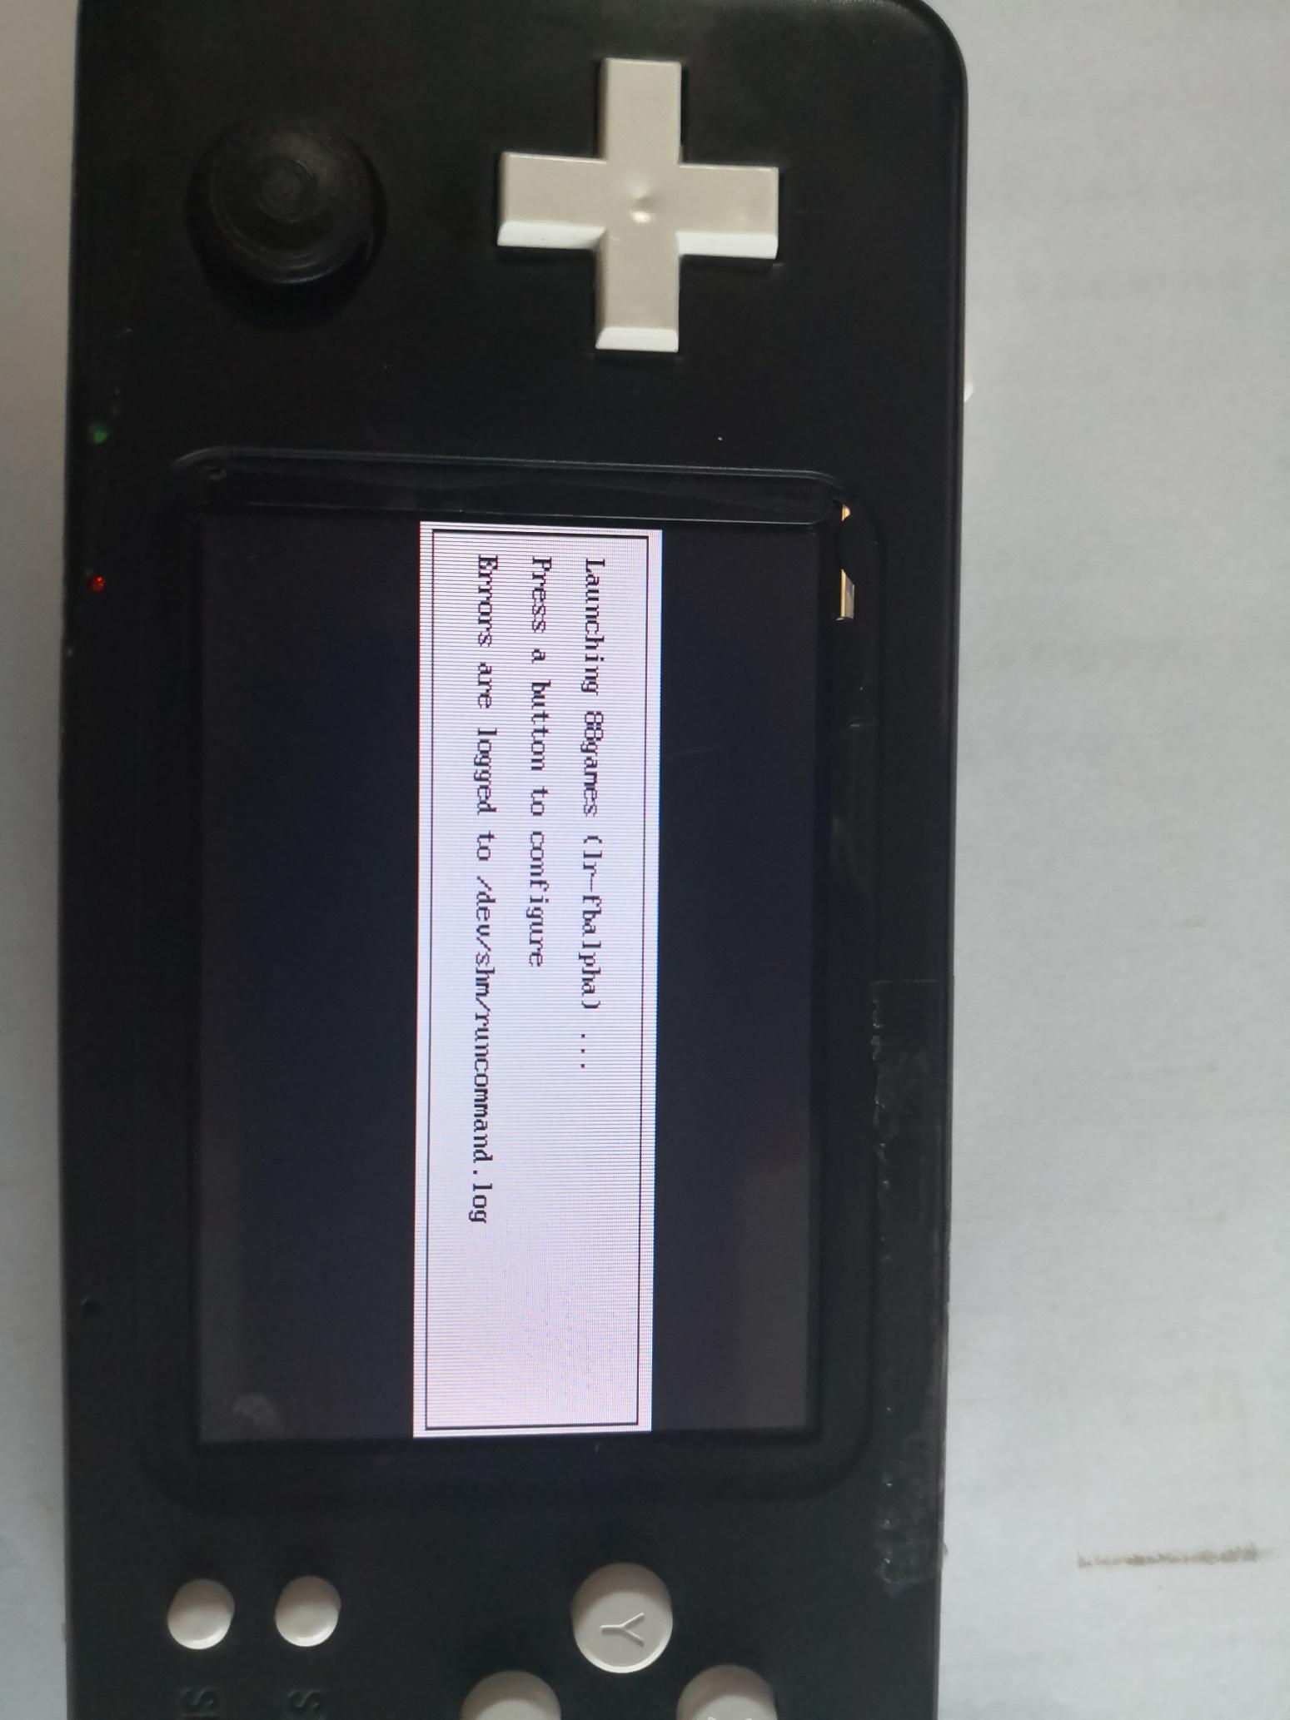

b）Select the first option (select the default simulator) and press the “A/B” button to enter;

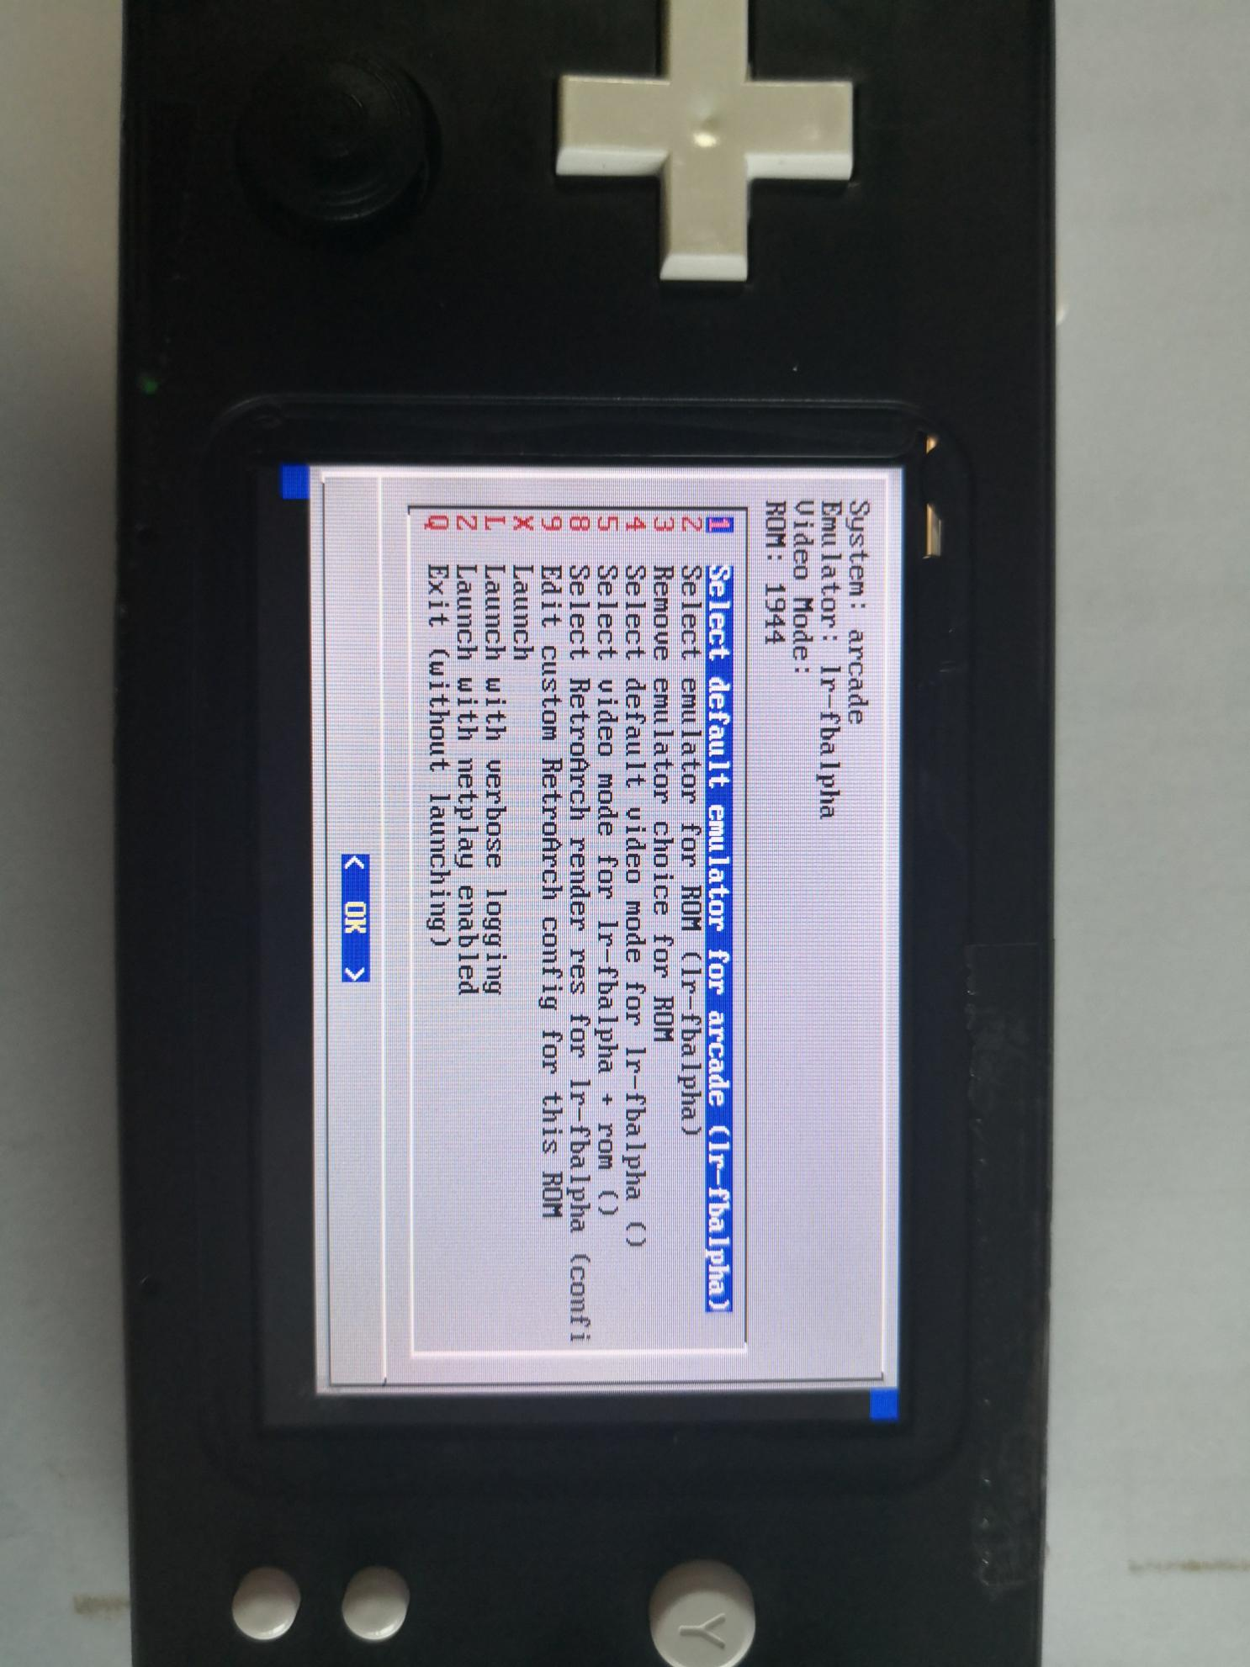

c）Press the “Cross Key” up/down to select the corresponding simulator, press the “Cross Key” left/right to select the operation to be performed (OK/Cancel). After selecting according to your own needs, press “A/B” to confirm the operation;

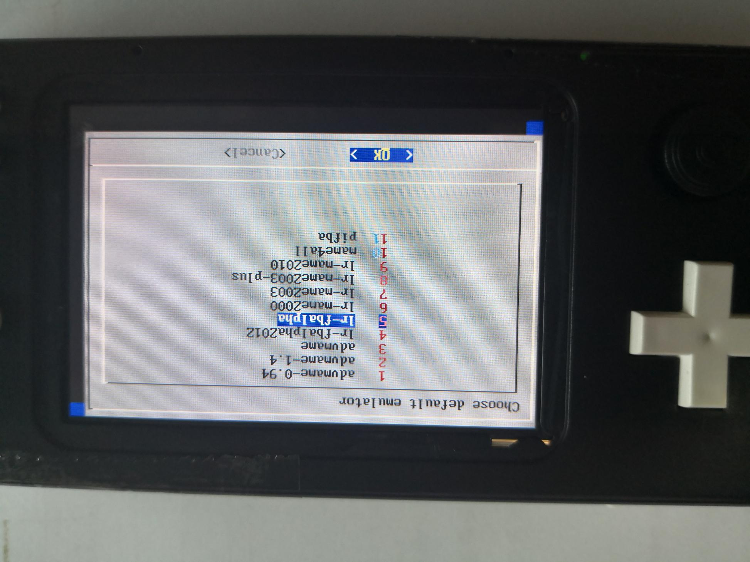

d、After completing step c, it will return to the menu of step b. At this time, we select “Launch” to load and run the game, or you can choose Exit to return to the main UI interface.

**Note:** The arcade simulator (ARCADE) needs to manually select the simulator for different versions. The game under the FBA folder needs to select the lr-fbalpha simulator. The game under the MAME folder needs to select the lr-mame2003 simulator.

Connecting to the Wireless Network

# Retro-CM3 Game Console User Manual

Thank you for supporting the Retro-CM3 program, the Retro-CM3 is a handheld game console which based on the Raspberry Pi Compute Module 3, its main features are as follows:

**Basic Parameters**

**a.** BCM2837 processor and 1GB RAM, quad-core CPU 1.2GHz ARM Cortex-A53, not overclockable;

**b.** Can be connected to a TF card, up to 128GB(This parameter is consistent with the type supported by the CM3 motherboard);

**c.** 3700mAh lithium battery；(Medium brightness GBA game for about 6 hours)

**d.** 3.2 inch IPS screen,viewing angle 170°-170°, resolution 480x320, hardware refresh rate 60Hz;

**e.** The same type rocker with PSV2000, perfect feel;

**f.** RTL8188 wireless module, support NETPLAY, support WIFI, support online games;

**g.** Using PCM5100/02 high-quality Hi-Fi rated sound card chip, supports automatic switching between speakers and headphones;

**h.** Retropie system, support MAME, NES, SNES, GB, GBA, GBC, PS1, PSP and other mainstream simulators.

# Basic Button Introduction

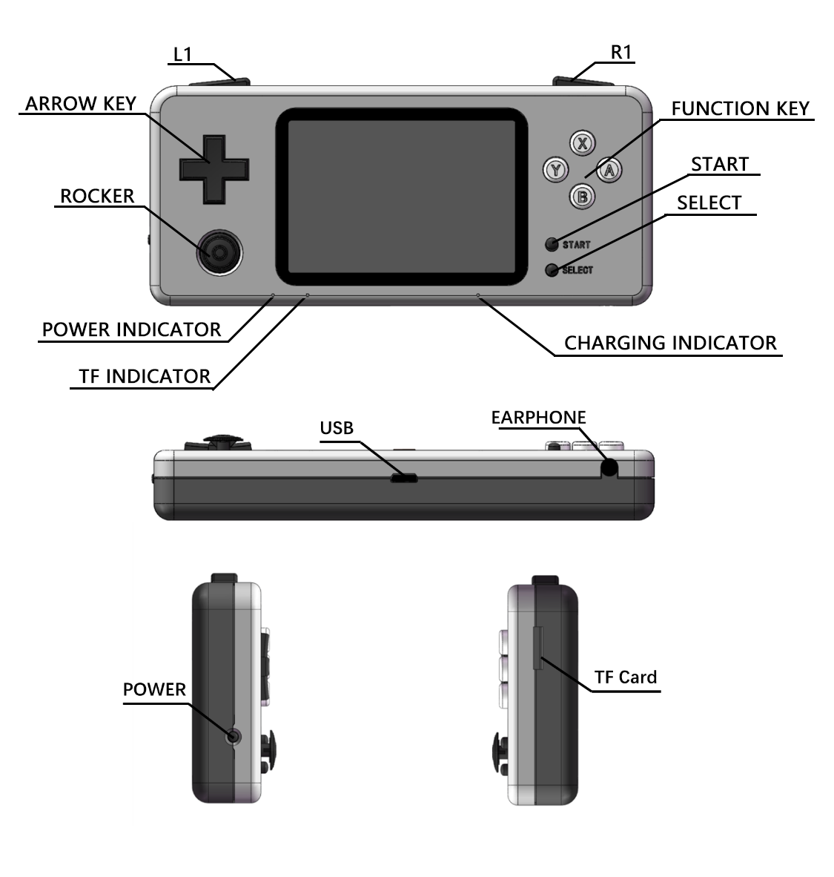

**Common Shortcut Buttons**

In the game, you can use the following shortcuts to operate (System default Value, which can be reconfigured in RetroArch):

SELECT+X：RetroArch menu;

SELECT+↑：Volume up

SELECT+↓：Volume down

SELECT+Y：Restart game；

SELECT+L：Quickly read the current SLOT archive (read instant storage);

SELECT+R：Quickly store archives to the current SLOT (save instant storage);

SELECT+←：Switch SLOT，decrease（instant archive save location -1);

SELECT+→：Switch SLOT，increase（instant archive save location +1);

SELECT+START：Exit to the system menu.

**Power operation**

Turn on the power: Press and hold the power button for 2 seconds, the power light will be on, then the power light will flash once to indicate that the power supply self-test is completed.

Turn off the power: In the Retropie system, press the START button on the main UI interface, select QUIT->SHUTDOWN SYSTEM, and wait for the machine to automatically power off.

1. Forced to turn off the power：

Press and hold the power button for 2 seconds the screen goes out.

Note: There is a danger of damage to the TF card by forcibly turning off the power while the ACT light is flashing!

Plug in the charger：Connect the machine to the charger through Micro USB cable, and the charging indicator lights up. It is recommended to use 5V2A charger.

Charging completed：The charging light goes out, or enters a continuous flashing state, indicating that charging is complete or timed out.

Battery indicator：The remaining battery power is less than 30%, the power indicator light starts to flash at intervals, every 5 seconds; the remaining battery power is less than 20%, the power indicator light starts to flash continuouslyC:\Users\Apple\AppData\Local\Temp\SGPicFaceTpBq\7460\004BE3EA.png, please charge as soon as possible.

Adjust brightness：When the power is on, press the power button once to cycle the 5-speed brightness.

Wi-Fi Switch：When the power is on, press the power button twice quickly, and the power indicator flashes twice to indicate that the operation is successful. Wi-Fi power is turned off by default.

**How to contact to WIFI network :**

**Method first:**

First confirm that the Wi-Fi power is on，go to the RETROPIE SETTING tab and select SHOW IP. A complete list of network devices appears on the screen. When the words “2:wlan0........................” are displayed below, the Wi-Fi power is turned on. If there is no wlan0 related word, the power is not connected. Please refer to how to turn on the Wi-Fi power.

|  |  |
| --- | --- |
|  |  |
| Wireless network is not turned on | Wireless network is turned on |

1）Connected without password

a）Select the RETROPIE SETTINGS tab to enter the WIFI option;

b）Select the corresponding SSID in the Wi-Fi list, and the system automatically connects;

2）connected with password

a）with the console off, take off the TF card and access it to computer, the computer prompts that there is a partition that needs to be formatted, click cancel;

b）Enter the first partition (boot partition), create a new text file wifikeyfile.txt;

c）Open the newly created file and enter the Wi-Fi information as follows (English quotation marks are included)：

ssid=”your wifi name”

psk=”your wifi password”

d）Select the RETROPIE SETTINGS tab to enter the WIFI option;

e）Select the "Import wifi credentials from /boot/wifikeyfile.txt" option to import the Wi-Fi password.

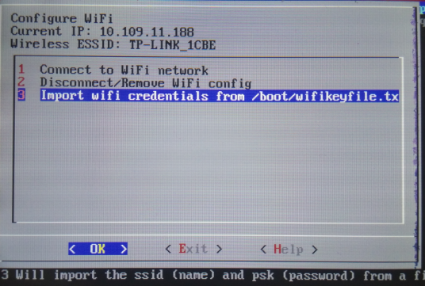

Note: This part of the settings can also be set by referring to the setting method of the raspberry pie official website wpa_supplicant.conf.

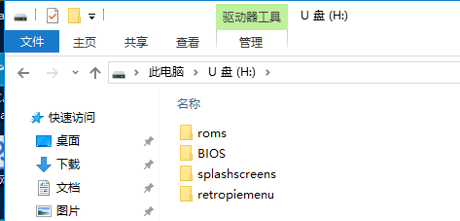

**Method second**

1）Create a new file named "wpa_supplicant.conf" and write the following: country=CN #corresponding country code

ctrl_interface=DIR=/var/run/wpa_supplicant GROUP=netdev

update_config=1

network={

ssid=”your wifi name”

psk=”your wifi password”

priority=1

}

Save and exit.

2）Take out the TF card, connect to the computer with the reader, and copy the modified "wpa_supplicant.conf" file to TF card boot file catalog.

3）Re-insert the TF card and turn it on. At this point, the console will automatically connect to the WIFI you just set.

4）The configuration file format of multiple WiFi connections is as follows: country=CN # Corresponding country code ctrl_interface=DIR=/var/run/wpa_supplicant GROUP=netdev

update_config=1

network={

ssid=”wifi-1 name”

psk=”wifi-1password”

priority=1

}

network={

ssid=”wifi-2 name”

psk=”wifi-2 password”

priority=1

}

。。。。。。

Save and exit.

For more information, please refer to **<https://retropie.org.uk/docs/Wifi/>**

**NETPLAY**

Retro-CM3 supports online games using the NETPLAY that comes with Retroarch.

1.In the same wifi environment, Retro-CM3 supports online operation and supports two-player games;

2.Note that the ROM of the two machines should use the same ROM file to avoid the situation that the connection cannot be made

For more information, please refer to <https://retropie.org.uk/docs/Netplay/>

**image File System**

We provide pre-installed driver image files, you can download them directly, or you can download the original image file from retropie's official website and add our image file.

Use our image file

A) Download address:

B) Decompress the image file and write the image file according to the "mirror burning" method;

C) Insert the TF card into the TF slot of the console, turn it on and you can play normally. If the power is too low, the Raspberry Pi will not start properly. Please connect a 5V3A power supply to charge the device. The CM3 supports charging while charging, and supports hot plugging.

D) When entering the system, you can use the arrow keys to select the emulator, for example, select CP1 and press “A” to confirm;

E) Enter the emulator and you will see many games, select and press “A” or “Start” button to confirm and start the game.

F) If you want to quit from the game you are playing, press the “Start” and “Select” buttons at the same time.

G) Please refer to “Common Shortcut bottons” for adjusting the brightness of the screen and adjusting the sound of the device.

How to set the short-cut key of Volume?

Press "Select" + X in the game to bring up the retroarch menu,>> Setting >> Input >> Input Hotkey Binds >>Volume + and Volume -, pls set the cross key “up” to the increase button, set the cross key “down” to the decrease button.

**Note: The shortcut keys be set by this method are only available in the game.**

**Add Rom**

Prepare the game

You can download the Rom: <http://coolrom.com/>

You can download games which are you like to your pc. If you are like the games of Sony Playstation,you can choose



Find the game you want and download it. For example

<http://coolrom.com/roms/psx/39719/Tekken_3.php> Click to download



Unzip the file you downloaded and get the game roms as below



**Update games**

Pls contact the console to internet.

You can see the IP address of this machine on the Wi-Fi connection interface or the Show IP interface. For example the IP address is 10.109.11.188

In the Computer Explorer, type [\\10.109.11.188,](\\\\10.109.11.188,) then press Enter

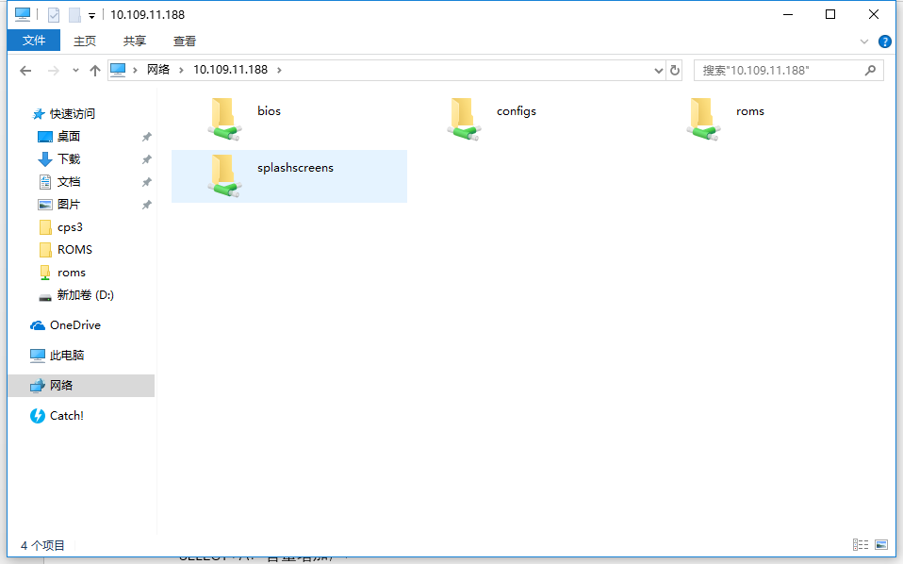

If prompted to enter a user name and password, enter the user name：pi，Password：raspberry。

b)Then there are 4 folders :bios,config,roms & splashscreens.

The corresponding emulator BIOS should be placed in the bios folder.

Corresponding emulator configuration file, patch file should be placed in the corresponding emulator folder in the config folder.

The corresponding game should be placed in the folder corresponding to the emulator name in the roms folder;

The corresponding boot screen can be placed in the splashscreen folder.

c) Open the roms folder

There are many folders, every folder corresponds to a simulator game, pls add games to correct folder,otherwise the games will be not recognized.

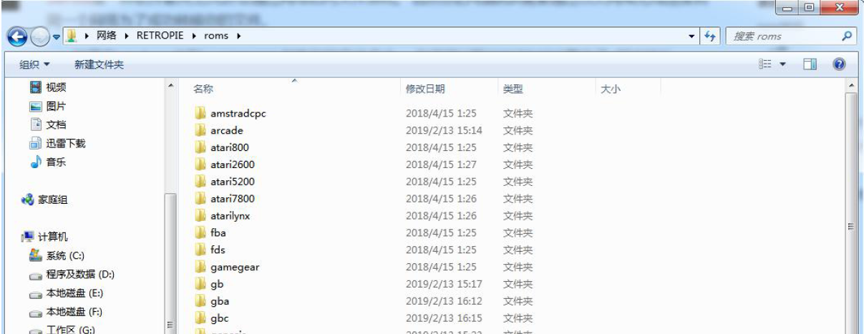

Simulator corresponding folder example:

|  |  |
| --- | --- |
| Arcade-FBA | roms\arcade\fba |
| Arcade-MAME | roms\arcade\mame2003 |
| SNES | roms\nes |
| PSP | roms\psp |
| PS1 | roms\psx |
| NES/FC | roms\nes |
| … | … |

Then restart Emulationstatio, you will find the added games.

**Note:**Don’t change any Directory Structure, only copy the roms to correct folder.

有关retropie设置的更多资料请阅读：**<https://retropie.org.uk/docs/>**